DIS-Points-Awl-WA- Columbia River

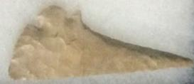

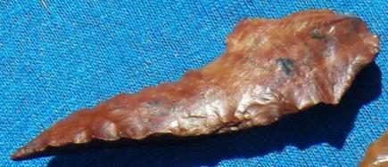

Columbia River Gem Points and Tools found in Kittitas County Washington. Found by Norma Berg in the 1940's and 50's on private land between Priest Rapids and Vantage Washington. I